Feature Load pay period ->>>

1. On click on load pay period -> Copy **[payrollDate],[CheckDate]column** from **PRREGISTERMAIN** database-table and paste it to Pay-Period table in BBC in column name **[StartDate],[EndDate]** before pasting make sure that data is not existed in database table
2. Make sure the new pay-period is active and old gets inactive

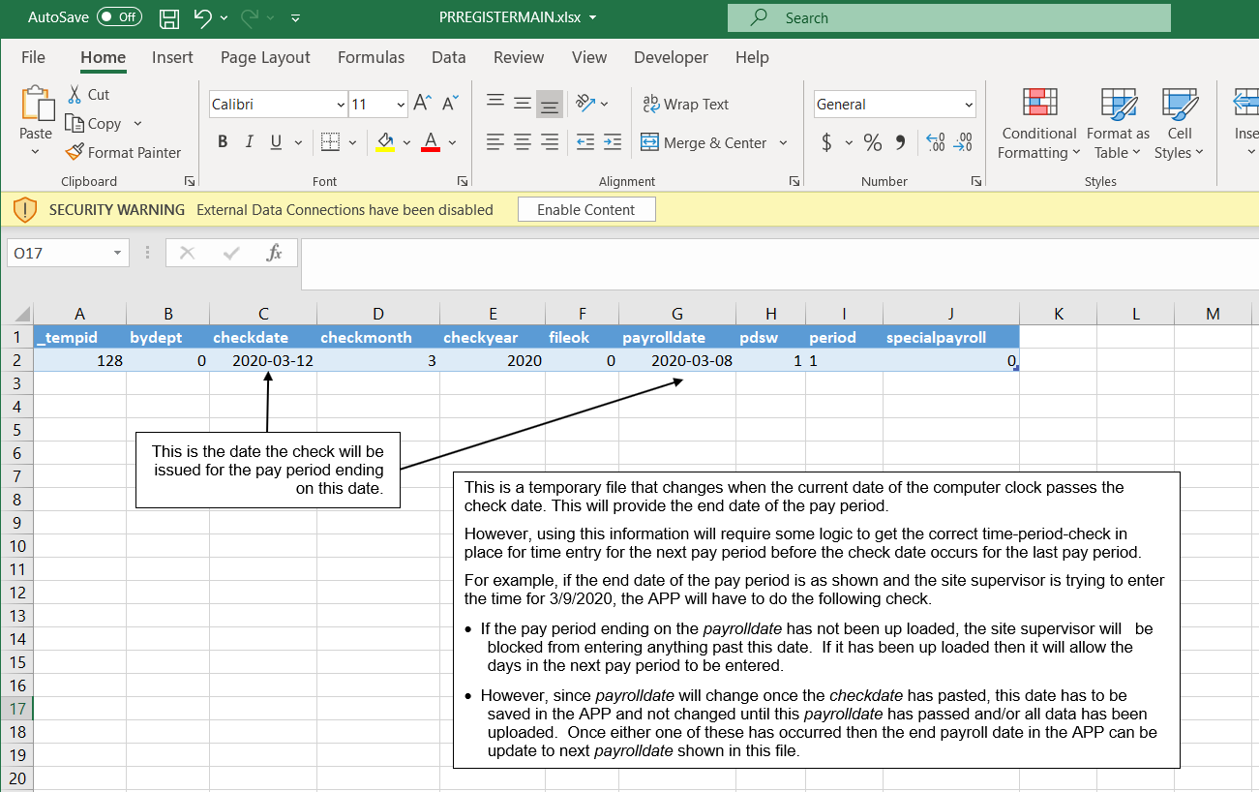

Feature Data Refresh ->>>>>

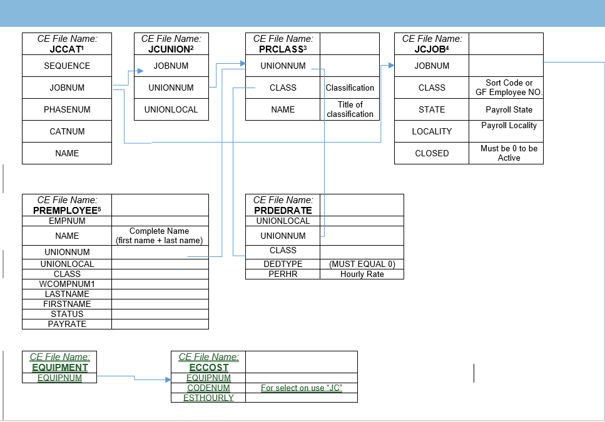

1. Copy these tables with particular columns and paste it to BBC- Database table name same as these tables
2. If every column value is same then don’t insert into new table otherwise insert into new table